30-08-2026

EXPERIMENT 20 – STUDENT, TEACHER, SUBJECT AND CODE

AIM
To write a Prolog program to create a database containing student, teacher, subject, and subject code information.

ALGORITHM
- Start the program.
- Define facts for students and teachers.
- Define subjects and their corresponding codes.
- Define relationships between students and subjects.
- Query and display the required information.

PROGRAM
student(aseem, cse).
student(arun, cse).
student(priya, ece).

teacher(ravi, cse).
teacher(meena, mathematics).
teacher(kumar, physics).

subject(ai, ai101).
subject(database, db102).
subject(network, cn103).

studies(aseem, ai).
studies(arun, database).
studies(priya, network).

OUTPUT

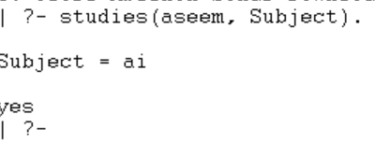

RESULT
Thus, the Prolog program was successfully executed to implement the student-teacher-subject database.

